**Week 1:**

**Day 1:**

Step 1:

* Install and set up PostgreSQL.
  + Reference: <https://www.youtube.com/watch?v=wTqosS71Dc4>

Step 2:

* Full PostgreSQL tutorial
  + Reference: <https://www.youtube.com/watch?v=qw--VYLpxG4>
    - \c [database name]: connect to a database
    - CREATE DATABASE [name];
    - Data Types: 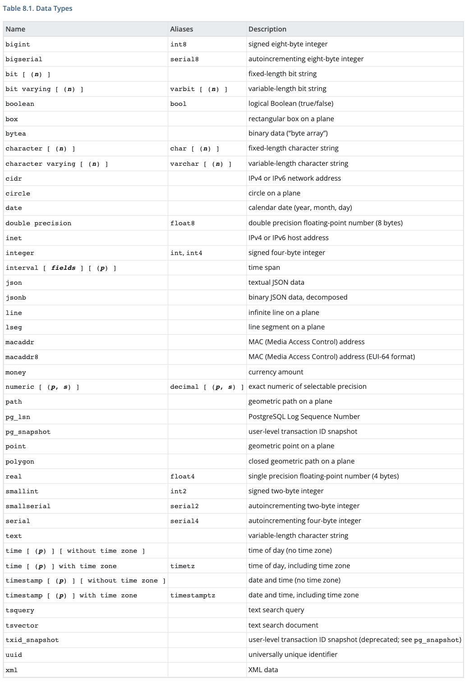

Step 3:

* Import the csv file into PostgreSQL:
  + Reference: <https://www.postgresqltutorial.com/postgresql-tutorial/import-csv-file-into-posgresql-table/>

1. Create a table:

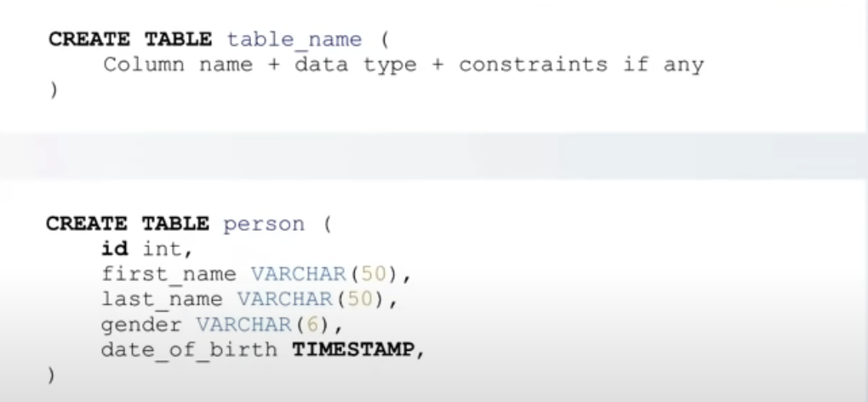

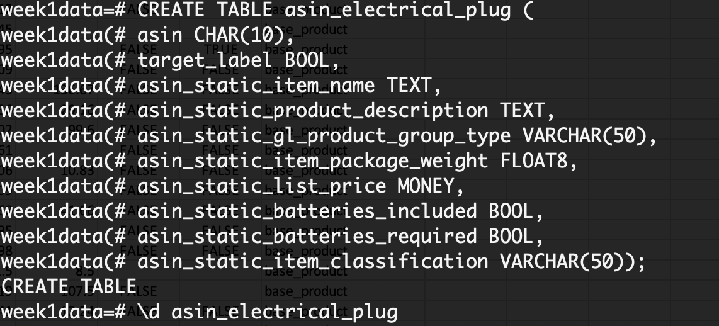

1. Import CSV file

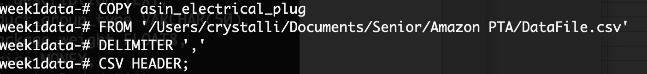

**Day 2:**

Step 1:

* Use Pandas Dataframe to add a new column into the csv file as uuid.

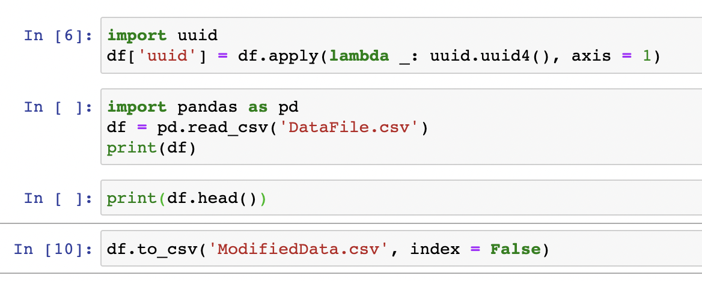

Step 2:

* Connect Python to Postgresql.
  + Reference: <https://www.postgresqltutorial.com/postgresql-python/connect/>
  + 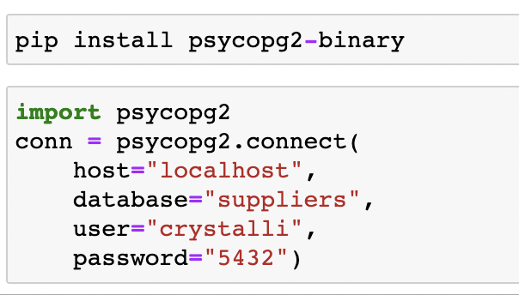

Step 3:

* Import the modified data to Postgresql.
  + 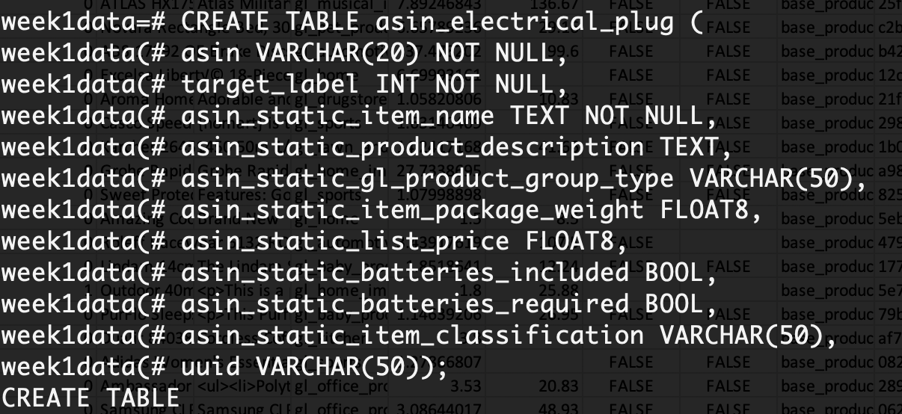
  + 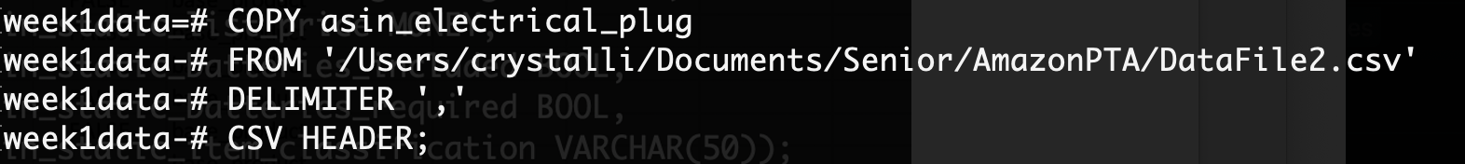

Step 4:

* Select data from the table
  + Select the asin of products whose list price is below $10.00.
    - 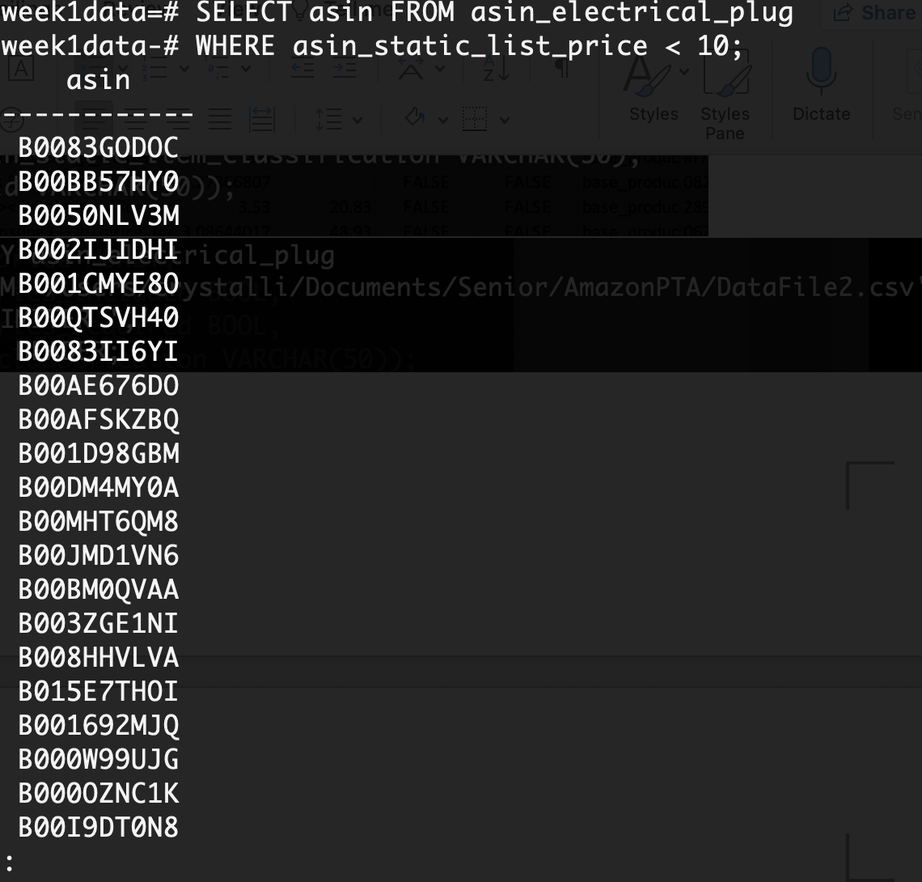

**Week 2:**

**Day 1:**

Step 1:

* Organize Python code into PyCharm
  + 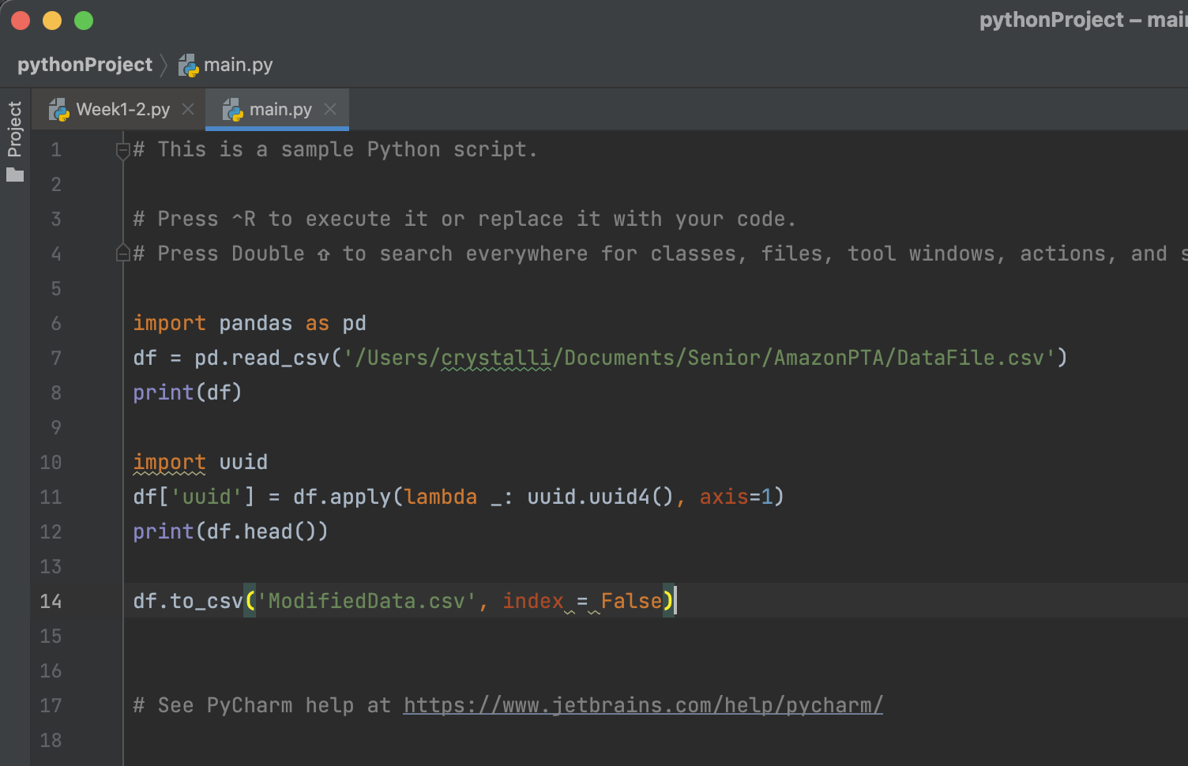

Step 2:

* Learn how to use Unit test in Python

Step 3:

* Set up Tableau and connect it with Postgresql
* Short Tutorial of Tableau
  + Reference: <https://www.youtube.com/watch?v=jEgVto5QME8>

**Day 2:**

Step 1:

* Revise + improve python code
  + One uuid for each file
  + Write functions to generate uuid
  + Save the file in a new directory called ‘UUID’
  + Cast any number columns using astype()
  + Change all NaN values to zeros

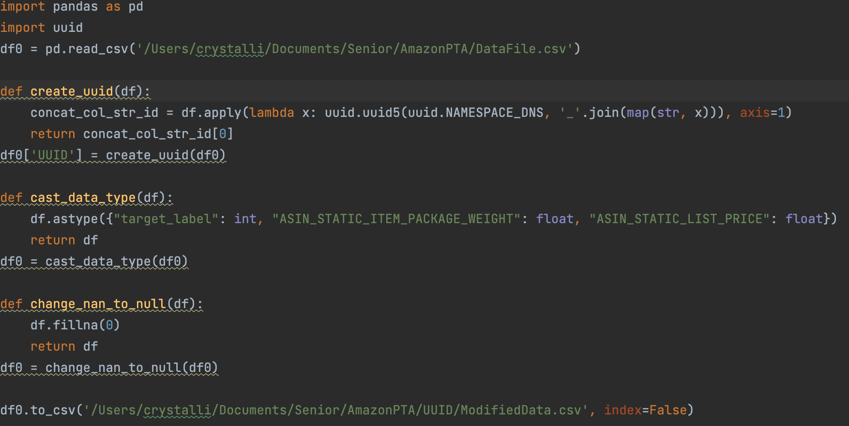

Step 2:

* Create pie chart, bar chart, and correlation matrix in Tableau and summarize them in a dashboard.
* Observe trend and give analysis

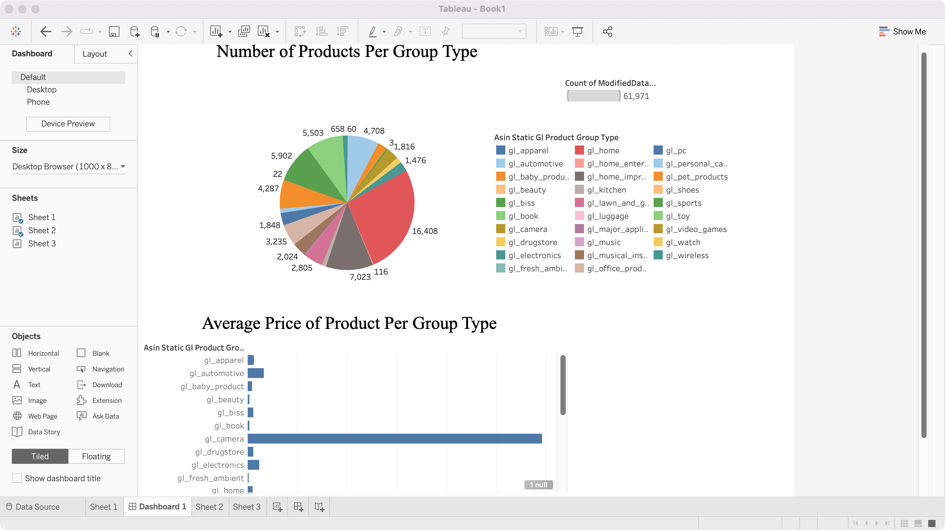

**Week 3:**

Day 1:

Step 1:

* Simplify python code
  + Generation of uuid
  + Change NaN into None

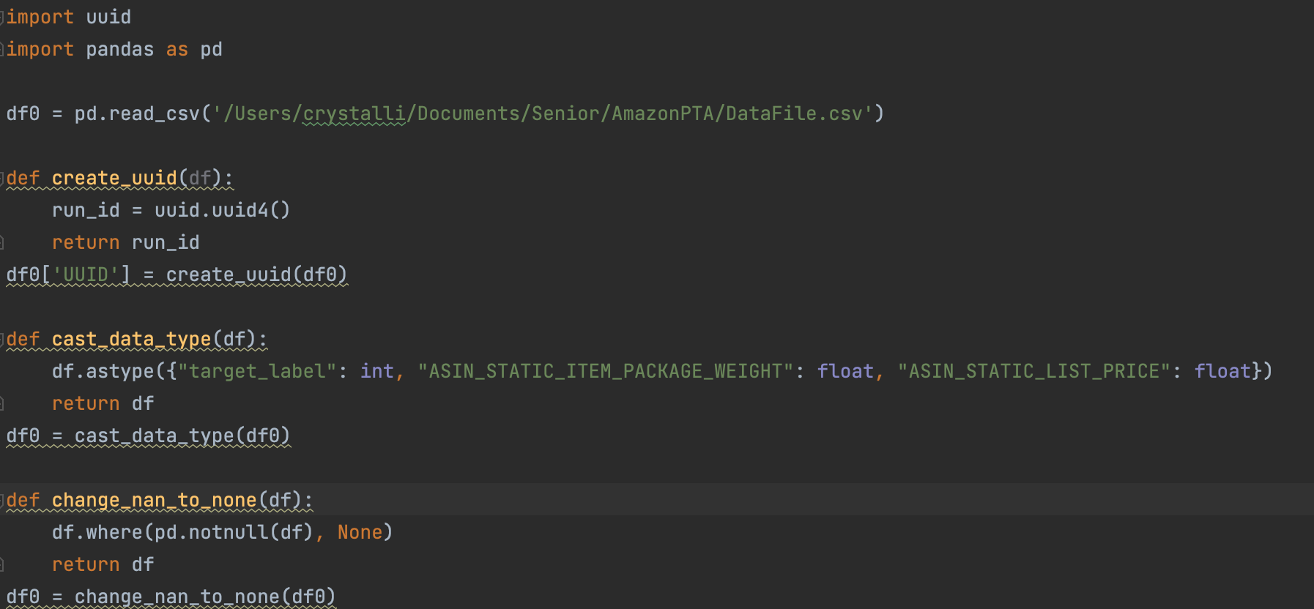

* + Save directly into Postgre
    - Reference: <https://medium.com/analytics-vidhya/part-4-pandas-dataframe-to-postgresql-using-python-8ffdb0323c09>

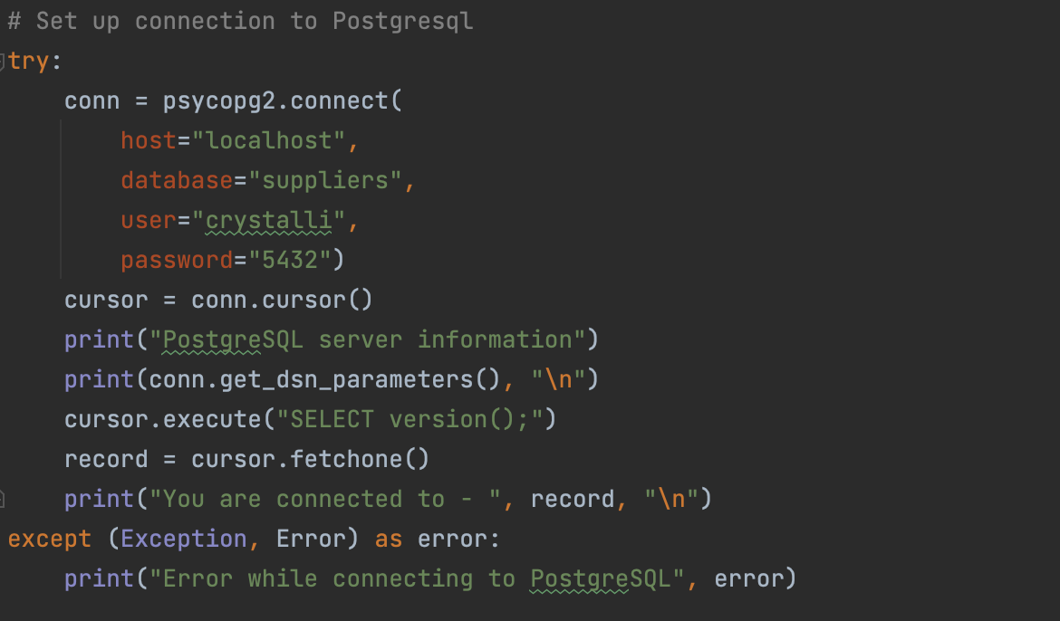

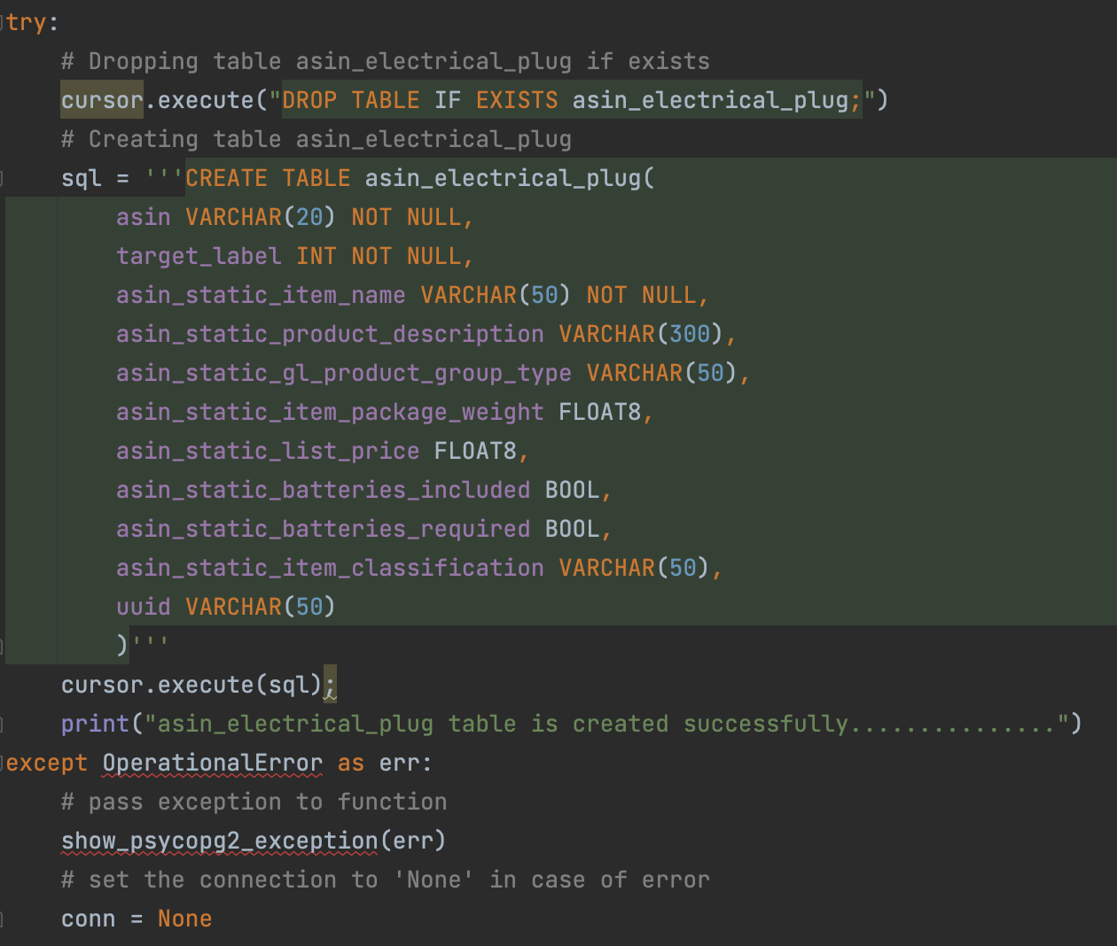

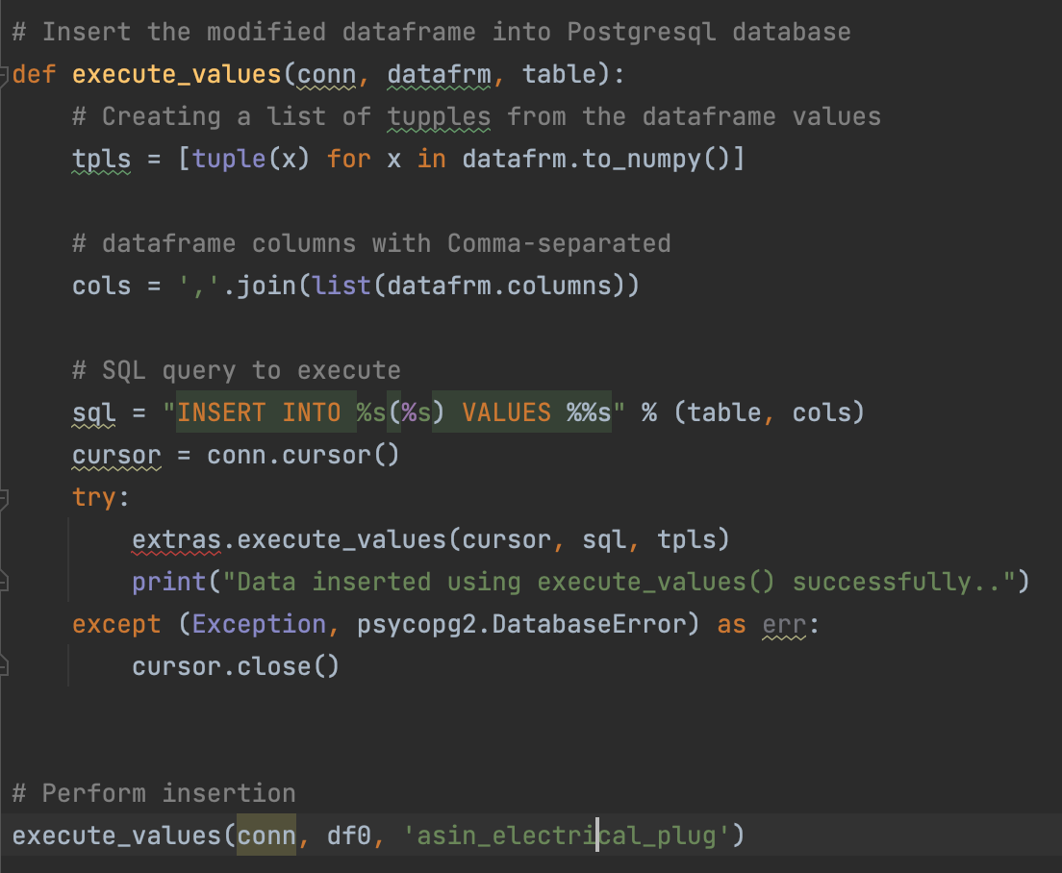

Step 2:

* Modify Dashboard
* 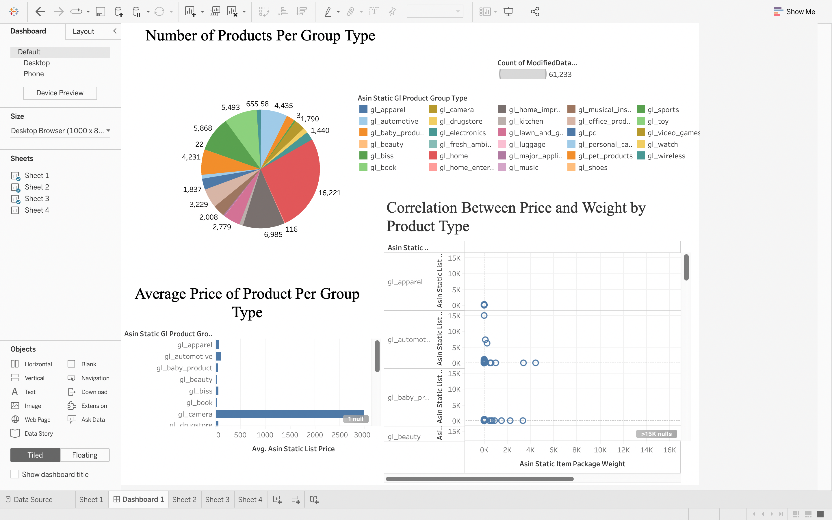
* Create bar graphs concerning batteries inclusion situation
* 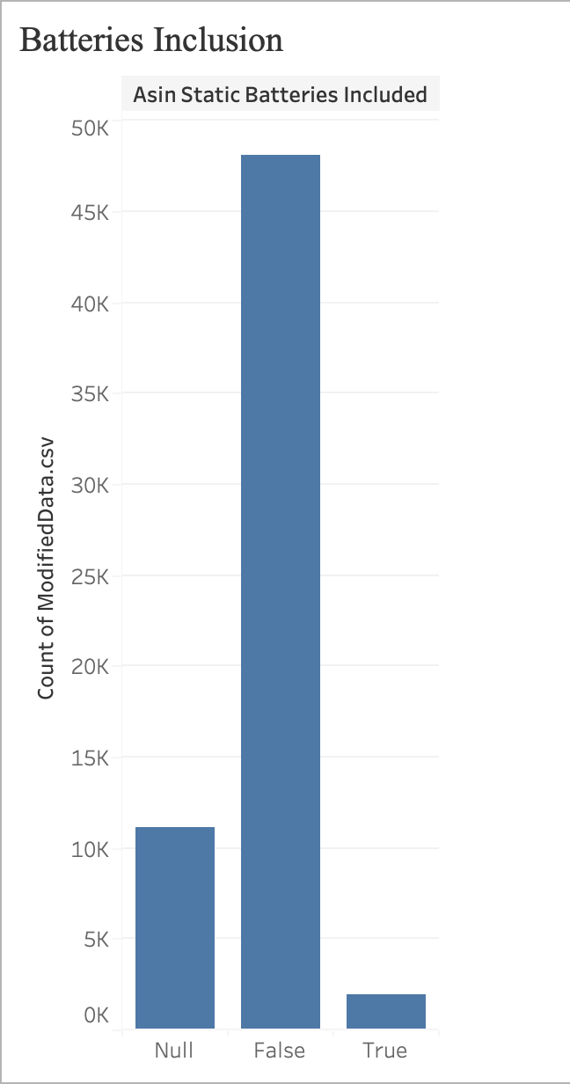

**Week 4:**

Step 1:

* Python code to create graphs
* Save them into a single pdf

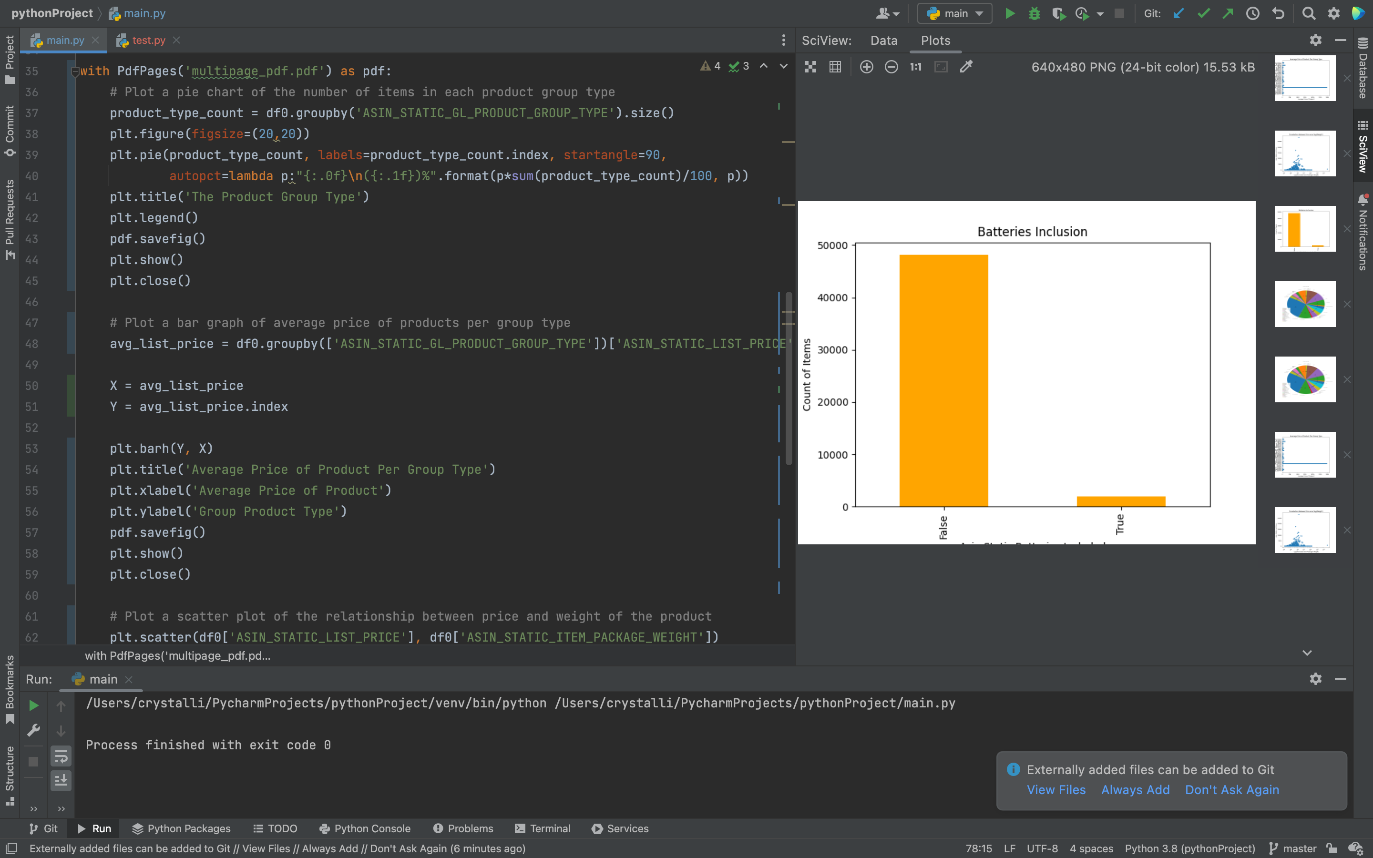

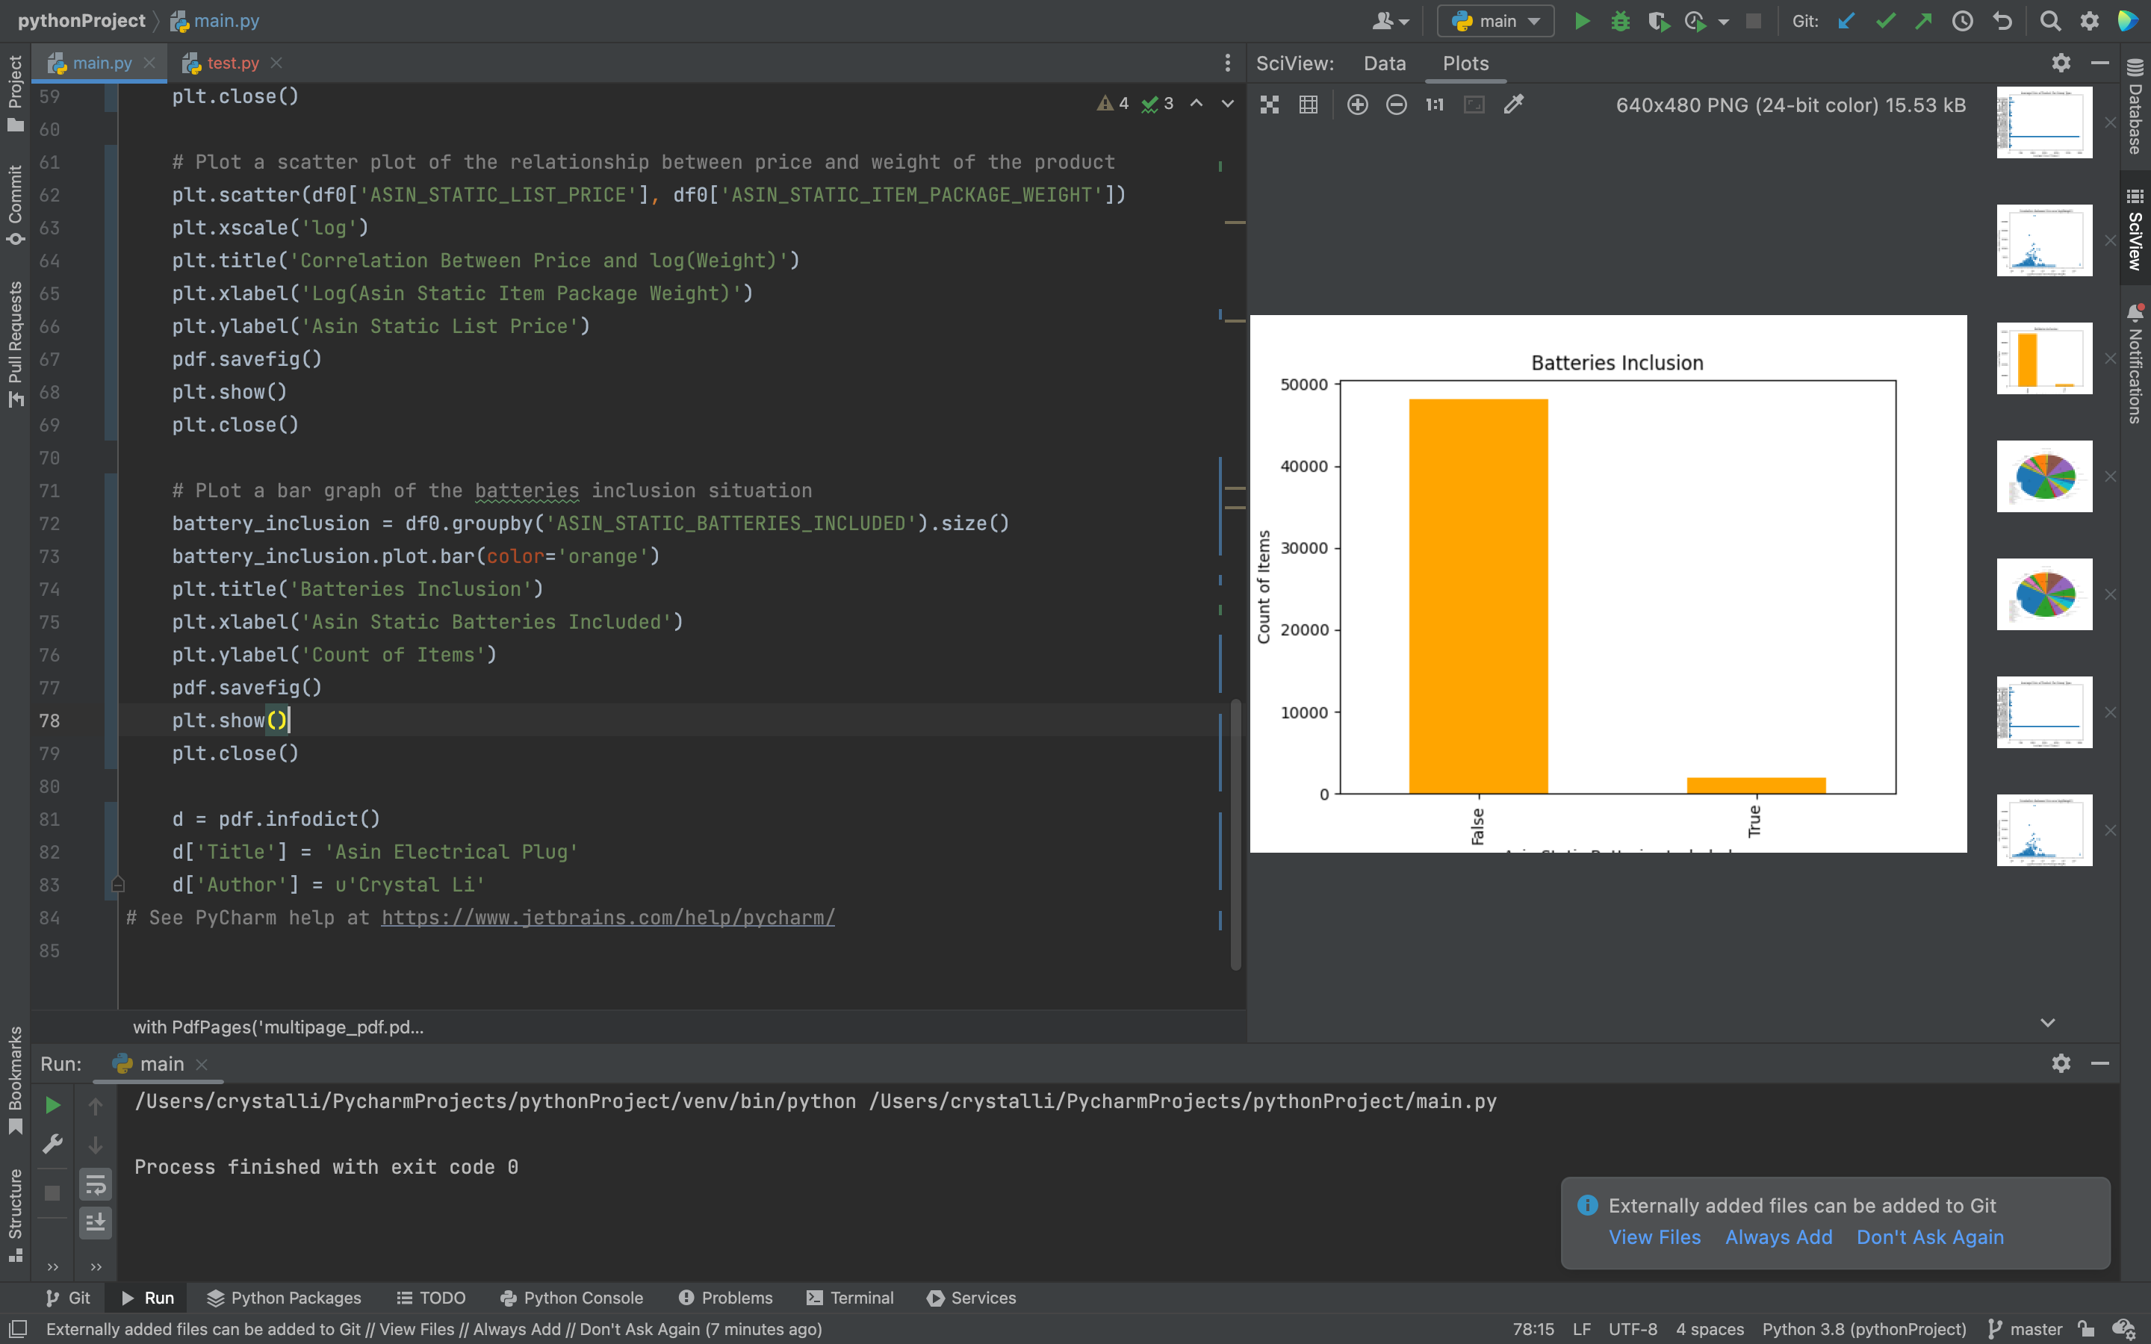

Step 2:

* Install/setup Apache Airflow
  + Reference:
    - <https://airflow.apache.org/docs/apache-airflow/stable/start/local.html>
    - <https://www.youtube.com/watch?v=YDDMm9M6SFA>

Day 2:

Step 1:

* Generate PDF(Productionize):
  + Reference(Add value labels to graphs): <https://www.geeksforgeeks.org/adding-value-labels-on-a-matplotlib-bar-chart/>

Step 2:

* Follow Jupyter notebook and learn KNN:

**Week 5:**

Day 1:

Step 1:

* Perform logistic regression
  + Reference: <https://www.youtube.com/watch?v=zM4VZR0px8E>
  + Used for classification tasks, better than linear regression
  + Sigmoid/logit function(keep the value between 0 and 1):
    - 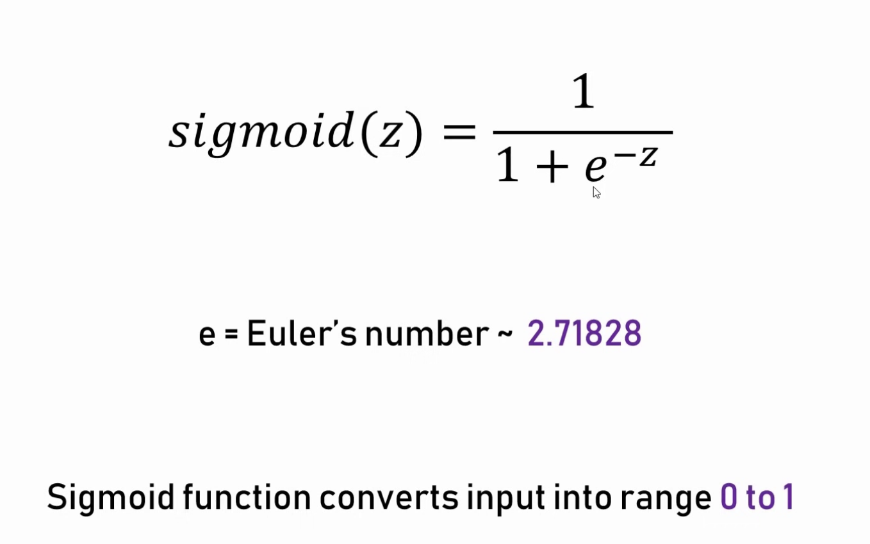
    - Confusion Matrix: 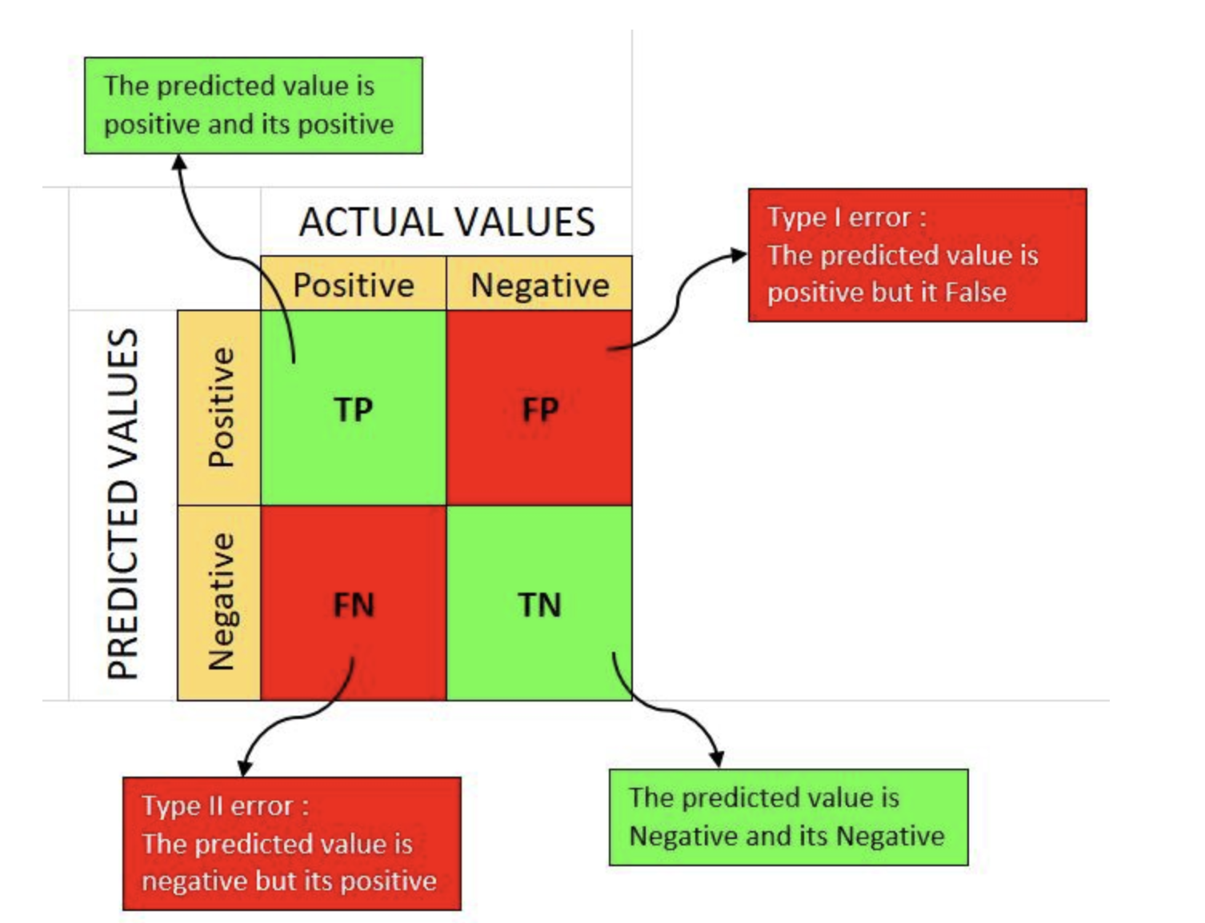
  + When performing standard logistic regression, the result is shown below:
    - 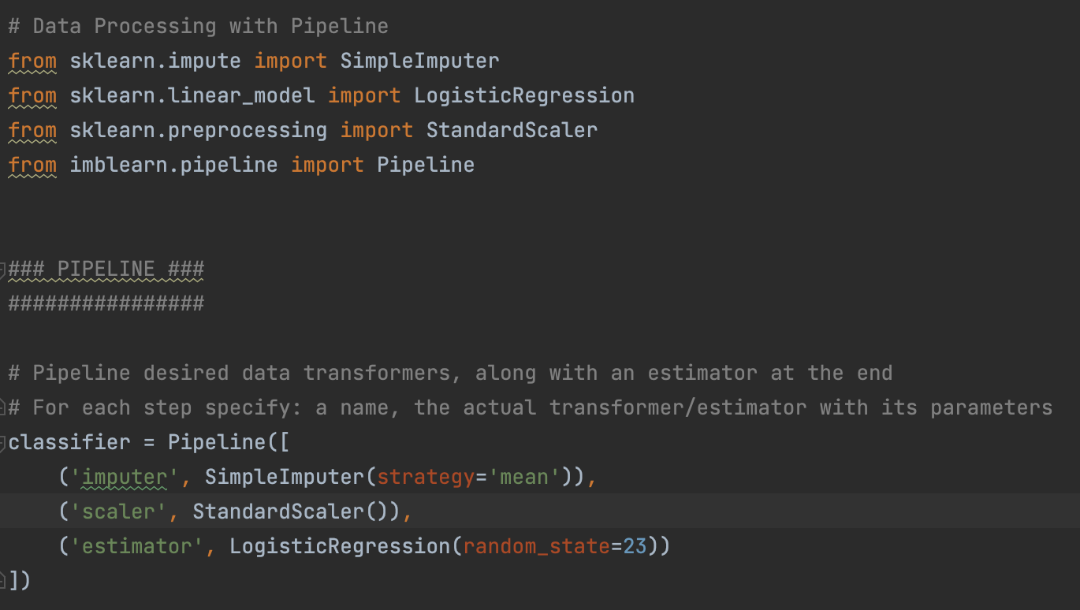
    - 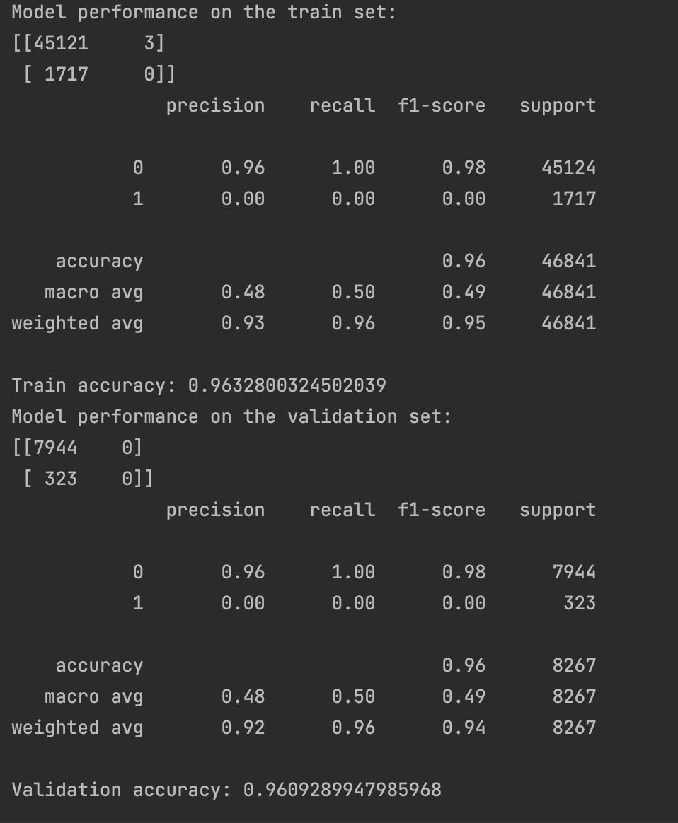
  + When oversampling the minority class using the SMOTE algorithm in Scikit-Learn and using StandardScaler, the result is given below: (Reference: <https://medium.com/@oluwabukunmige/logistic-regression-in-scikit-learn-a-step-by-step-process-32f546241f32>
    - 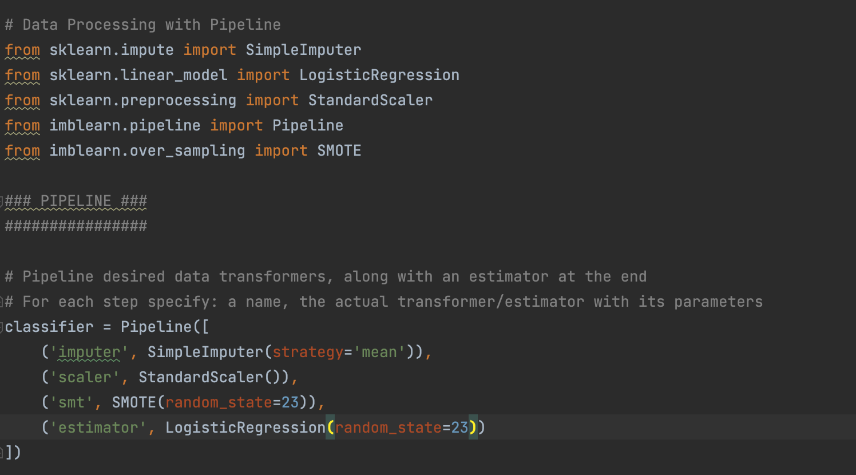
    - 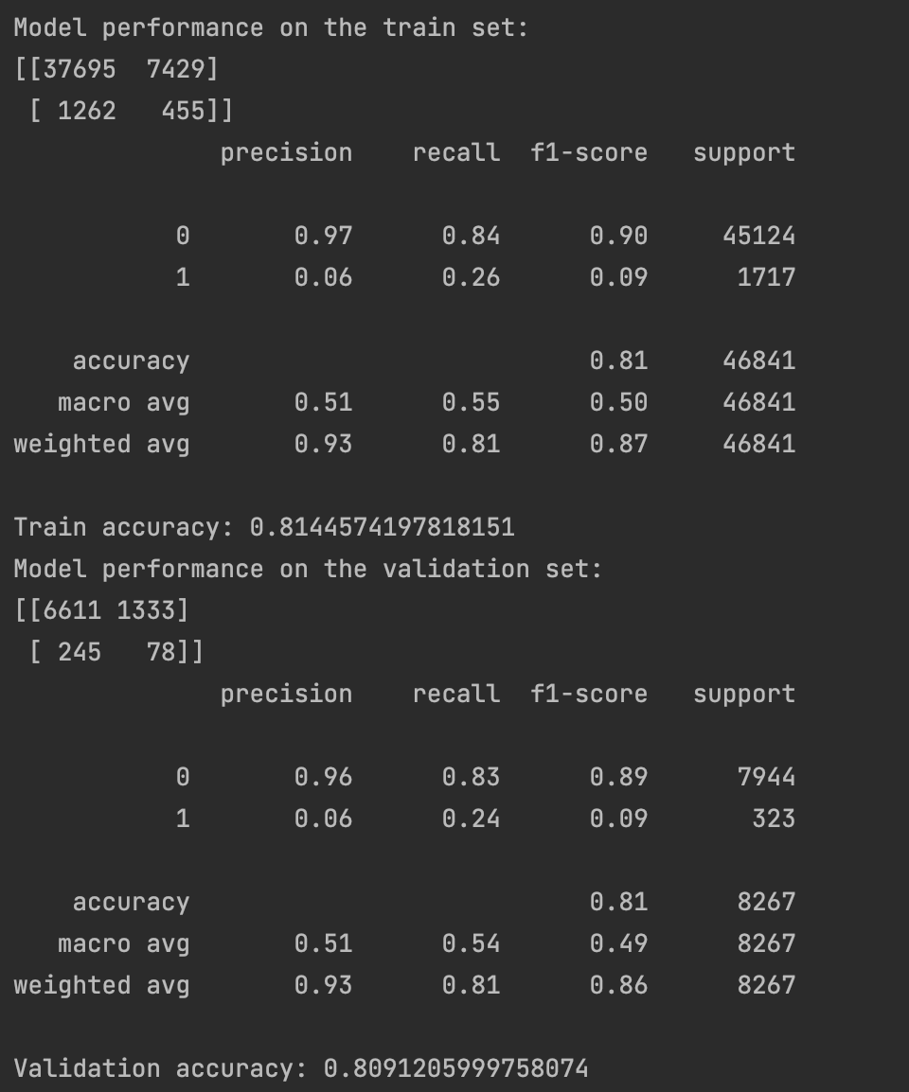

Step 2:

* Perform SVM
  + Each object is represented as a point in a n-dimensional space, where its coordinates usually called features.
  + SVM perform the classification by drawing a hyperplane so that all points of one category are on one side while the other points are on the other side.
  + Characteristics: easy to understand, implement, use, and interpret. Best of use with small sample size. (larger sample size: kernel trick, nonlinear transformation)
  + Margin: the shortest distance between the observations and the threshold.
* SVM results
  + 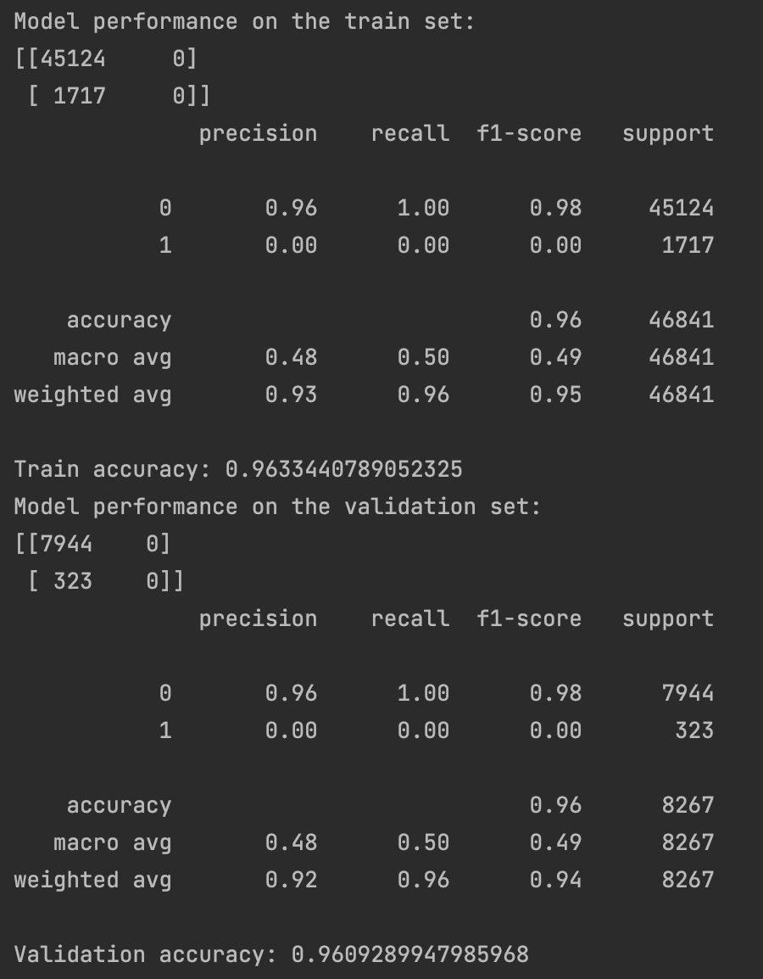

Step 3:

* Compare results of KNN, logistic regression, and SVM.
  + The model accuracy of logistic regression and SVM without kernel are a bit lower than KNN.

**Day 2:**

Step 1:

* Learn Decision tree

Step 2:

* Learn Random Forest Algorithm
  + Divide dataset into random batches and build decision tree based on each sample: a forest is formed
  + When an input is given, the algorithm takes the majority result.
  + Overfitting problem
  + 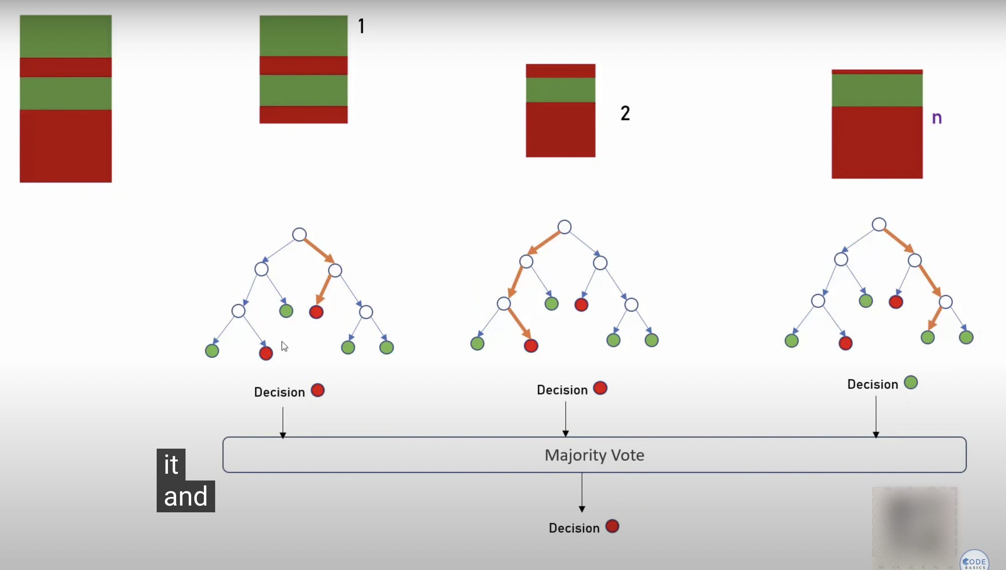
* Perform Random Forest
  + 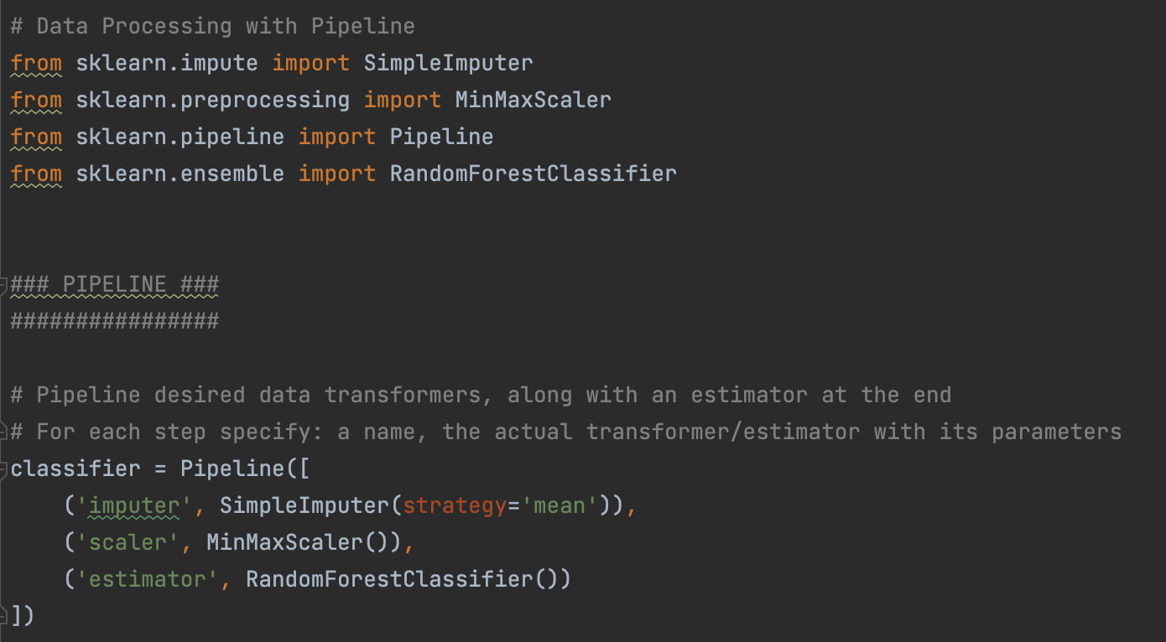
  + 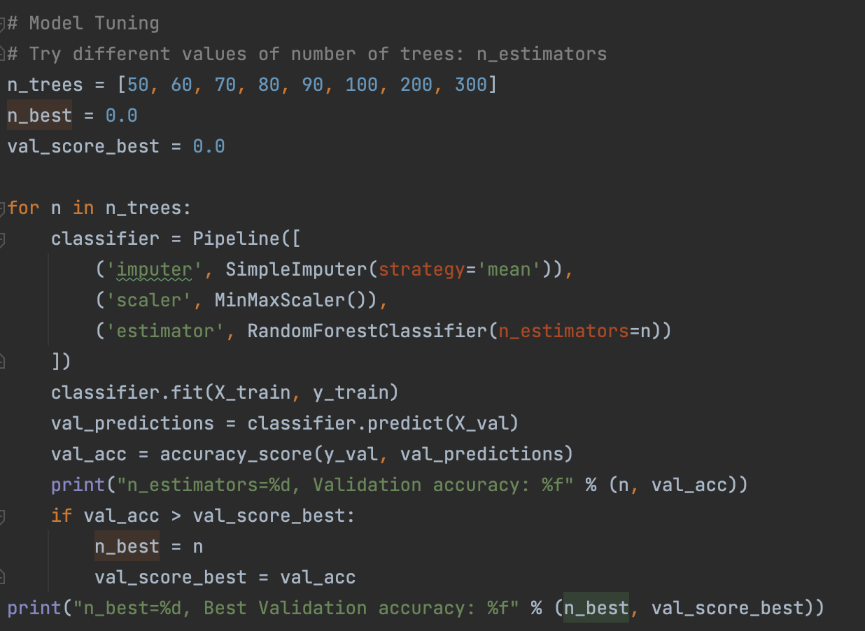
  + 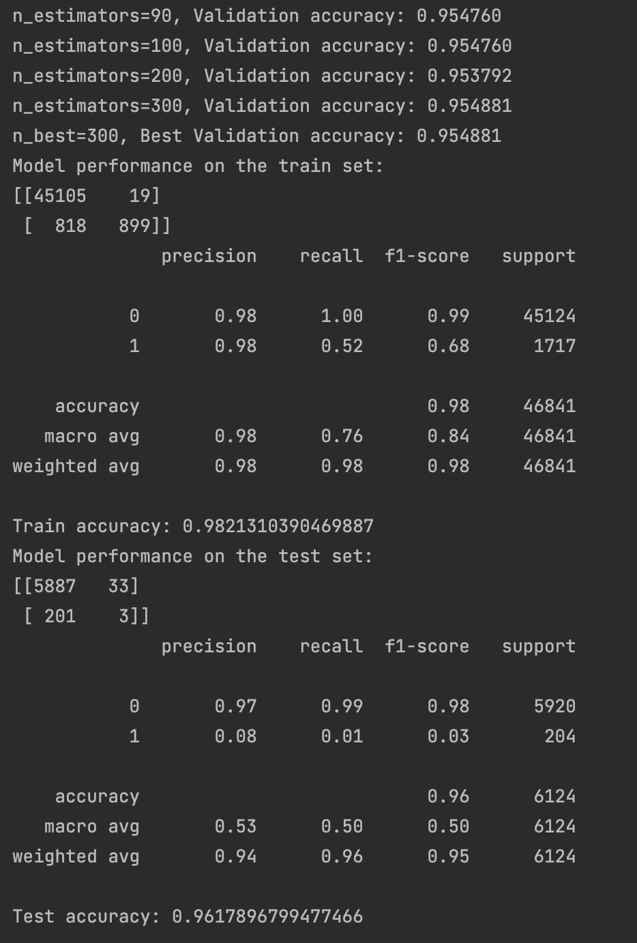

Step 3:

* Learn Gradient boosting algorithm
  + Predicting output target feature by boosting of optimally weighted sequentially built decision trees.
  + Boosting is used for simultaneously lowering squared bias error and variance error sources of sequentially built decision trees.
  + Overfitting problem
  + 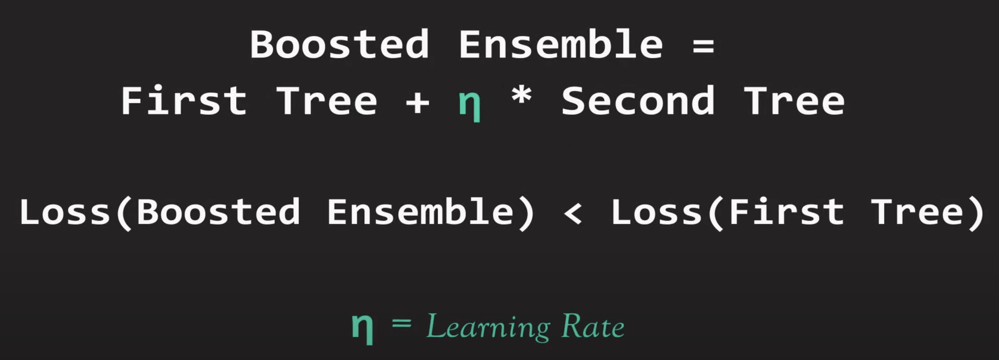
  + 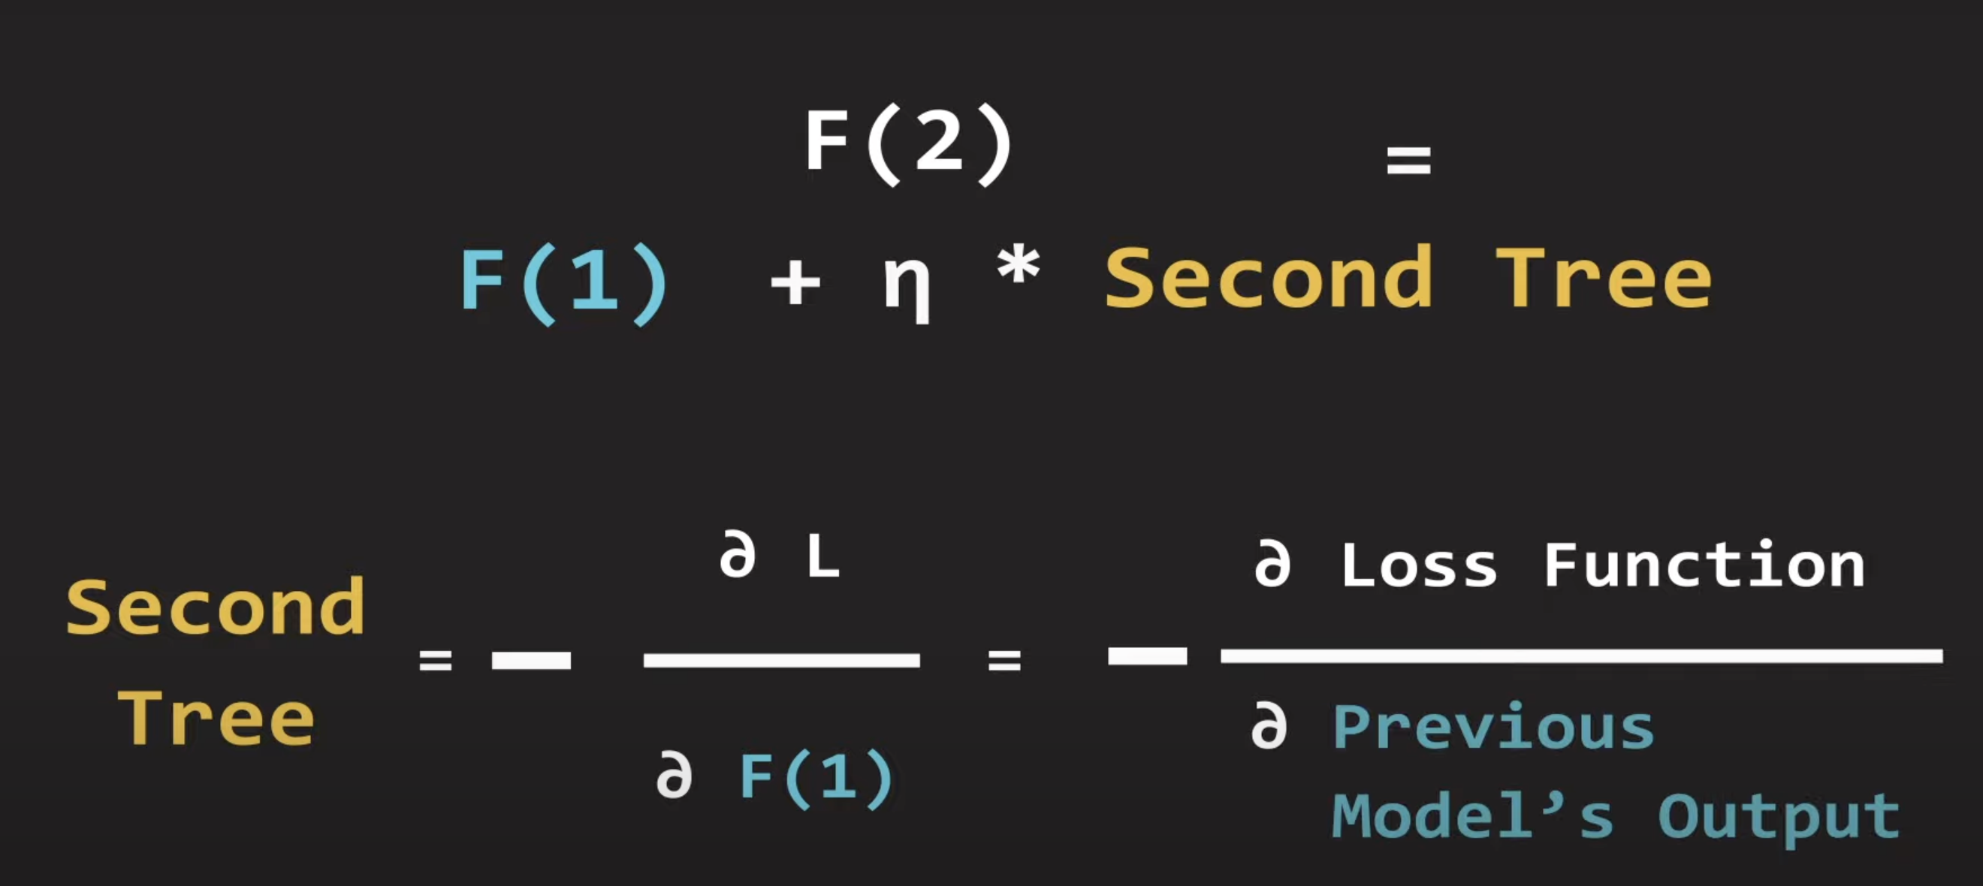

Step 4:

* Perform Gradient Boosting
  + 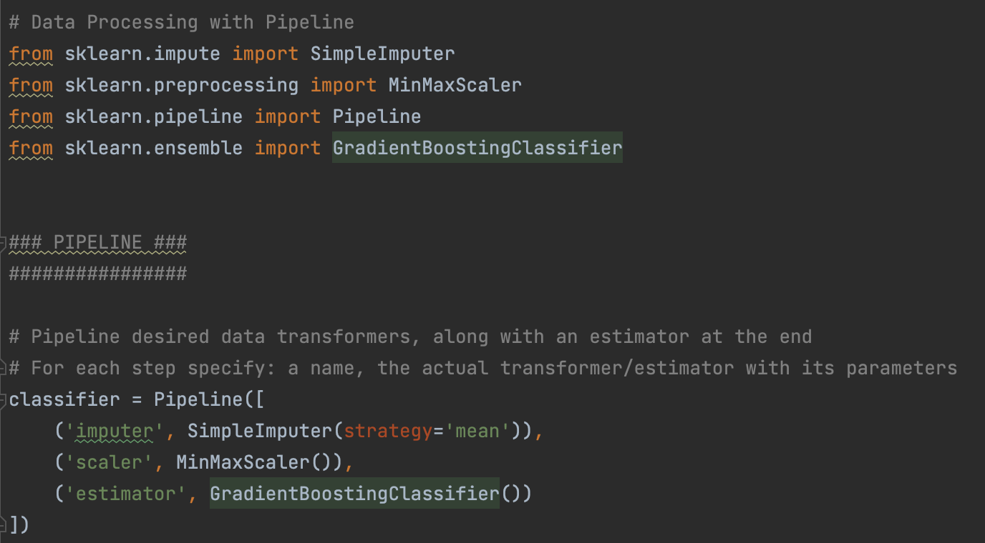
  + 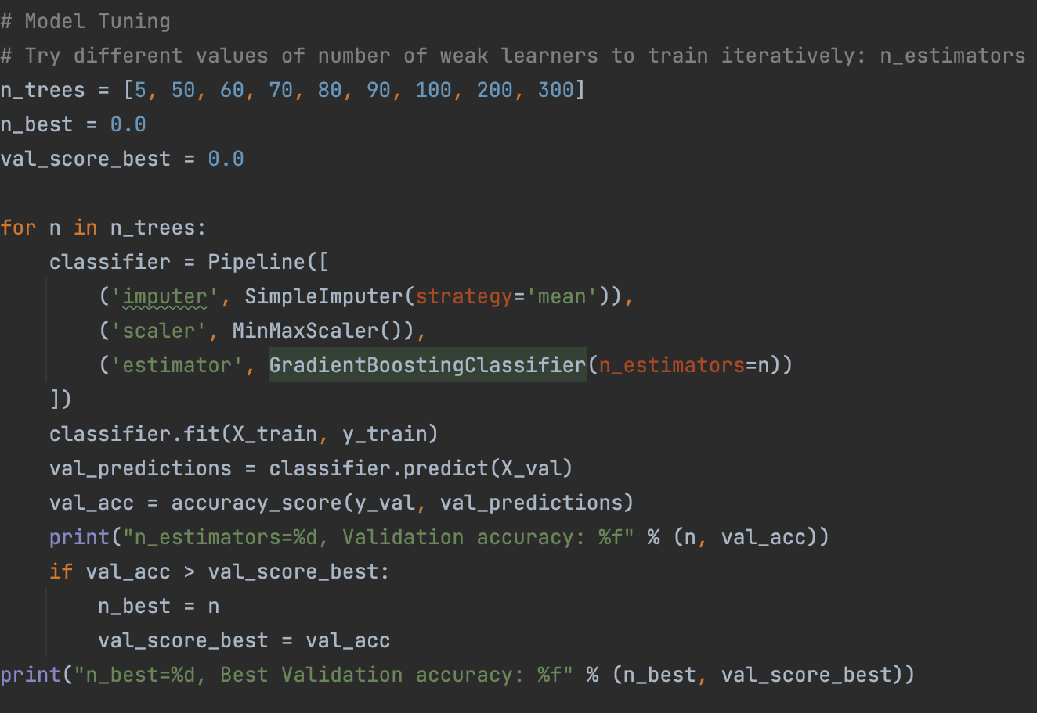
* Result of Gradient Boosting
  + 